WEEKLY NEWSLETTER – 17th February 2025

- Compression bandaging Local Enhanced Services – guidance for GPs
- Oliver McGowan Training – Free until 31st March 2025!
- GPCE Guidance, media and contacts
- GP Collective action – Secondary care guidance
- Update to medical certificate of cause of death guidance
- NHS Digital weight management programme

1.Compression bandaging Local Enhanced Services – guidance for GPs

This information has been provided by GPC, and we thought it may be of interest to you.

Please find attached guidance for practices who may be considering taking on a local enhanced service for complex dressings such as compression bandaging or indeed withdrawing from this enhanced service as part of collective action. A recent Coroner's case has highlighted some significant pitfalls that all GPs undertaking this work should be aware of.

2.Oliver McGowan Training - Free until 31st March 2025!

The Oliver McGowan training project team have now released ALL dates and sessions on the links below and booked all our training teams – once these are fully booked, they will NOT be able to provide or add any further dates or venues.

To Book

Go to website
or

scan the QR code for the relevant level of training


3.GPCE Guidance, media and contacts

- The BMA’s GP campaign ‘Protect your patients, protect your GP practice’ webpage

- GP partners collective action: 9 actions you can take

- GPCE Safe Working Guidance Handbook

- Guidance for GP collective action for Sessional GPs and GP registrars

- Downloadable waiting room/website videos and infographics for practices.

- Campaign materials (patient leaflets, lanyards, badges, window stickers) on the BMA rep Hub

- Read more about the work of GPC England and practical guidance for GP practices

- See the latest update on X @BMA_GP and read about BMA in the media

- Contact us: info.lmcqueries@bma.org.uk

4. GP Collective action – Secondary care guidance
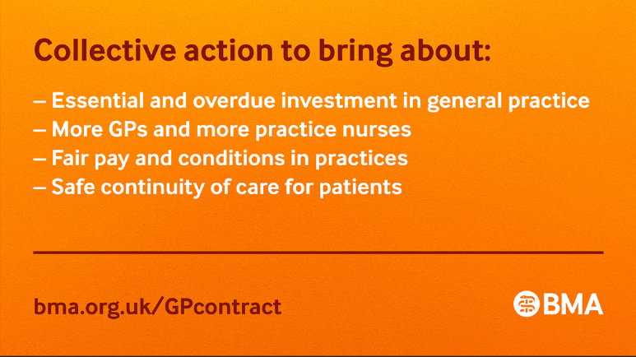
Thank you all for continuing to develop and expand on our collective action to protect our patients and practices.

We recognise the particular challenges across the primary and secondary interface, and want to ensure all specialist colleagues are aware of the purpose and aims of GP Collective Action. To this end GPC England and the UK Consultants Committee have developed explanatory resources hospital and trust-based colleagues.

Our new webpage https://www.bma.org.uk/secondarycareGPaction outlines how secondary care colleagues may be affected and ways they can support GPs in this campaign. This includes a downloadable PowerPoint presentation which LNCs (Local Negotiating Committees) can use in their patch, an at-a-glance fact sheet that can be displayed in Trusts, and a recorded webinar offering further insights.

Please also continue to refer to our collective action Protect your patients, protect your practice webpage, which explains in more detail the nine actions that practices can choose to take. It also contains more information such as the Safe Working Guidance Handbook, Campaign resources and Patient materials.

As negotiations for the GP contract 2025/26 progress, this is a pivotal moment for all GPs to unite as a profession – not just for safe and sustainable general practice, but for a safe, sustainable and stronger NHS too.

5.Updates to medical certificates of cause of death guidance

DHSC has updated their guidance for medical practitioners completing medical certificates of cause of death (MCCD) with regards to implantable medical devices and medical practitioner qualifications. Medical practitioners are asked to adhere to the guidance to make sure death certification and registration are processed swiftly.

GP practices are asked to check they have enough MCCDs to last until the end of April 2025. Guidance is available on ordering and retaining MCCDs and counterfoils, and what to do with those in use before 9 September 2024.

6.NHS Digital weight management programme

The NHS Digital weight management programme is available via self-referral for NHS staff. Over 32,000 NHS colleagues have utilised the offer.

The programme takes 12 weeks to complete. Participants can choose a weight management plan to develop healthier habits and lose weight. Find out more about the staff offer. The programme is available to the wider public and 385,000 people have been referred having met the criteria of living with obesity plus a diagnosis of diabetes, or hypertension, or both. Find out how to refer into the programme.

Please note our office contact times remain 10:00-16:00 and any queries on the day should be directed to birmingham.lmc@nhs.net. If you do call the offices, then please leave a message as this will be transferred direct to our emails and we can respond quicker.

Please note that the LMC are unable to accept calls or hold communications with patients, we are GP representatives, and we would respectfully ask that Practices do not advise patients to contact us. Could we also remind Practices that any copies of patient related correspondence MUST be anonymised as the LMC cannot accept patient identifiable data.

Helpful Links:

BMA Website: https://www.bma.org.uk/advice-and-support/gp-practices

GOVERNMENT Website: https://www.gov.uk/coronavirus for recent and upcoming changes, guidance & support.

NHS ENGLAND Website: https://www.england.nhs.uk/

